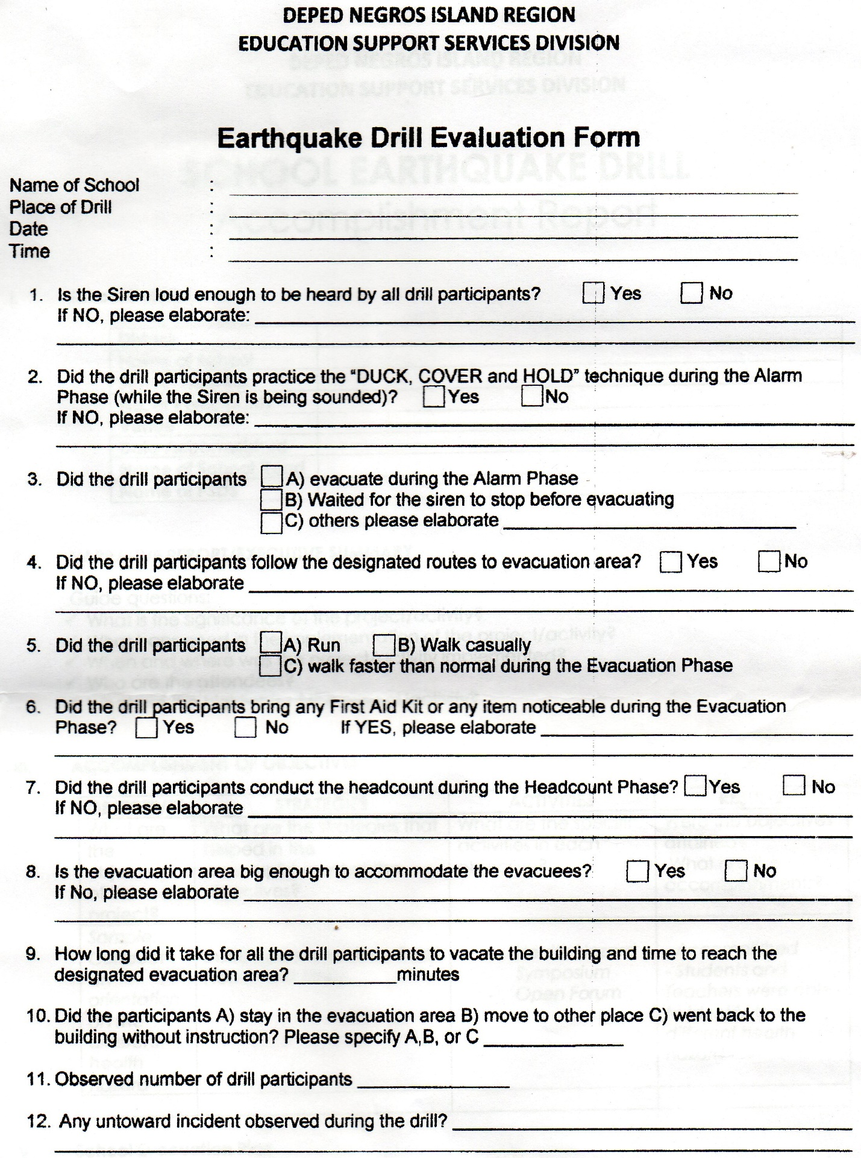

**NO**

**317**

**A**

2:00 PM

LA GRANJA NHS-YUBO EXTENSION (COVERED COURT)

FEBRUARY 15, 2018

LA GRANJA NHS-YUBO EXTENSION

**3**